ASSIGNMENT-2

# 

|  |  |
| --- | --- |
| **TEAMID** | PNT2022TMID17666 |
| **PROJECTNAME** | IOT BASED SAFETY GADGET FOR CHILD SAFETY MONITORING AND NOTIFICATION |
| **NAME** | VASUNTHARA D |
| **ROLLNO** | 611619205055/319UIT055 |

Build a python code. Assume u get temperatureand humidityvalues(generatedwithrandomfunctiontoavariable)andwriteaconditiontocontinuouslydetectalarmincaseofhightemperature.

# program:

importrandomtemp=random.randint(0,100)humid=random.randint(0,100)print("Note:")print("NormalTemperatureLevel is 50°C") print ("Normal HumidityLevelis50%")

print(" ")

if(temp>=50):

print ("Temperature is High",temp,"°C")else:

print ("Temperature is Normal",temp,"°C") if(humid>=50):

print ("Humidity is High",humid,"%")else:

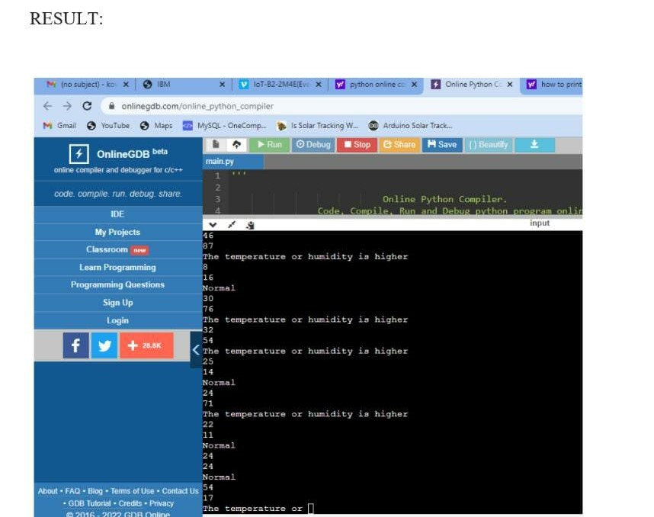print("HumidityisNormal",humid,"%")